230701228

# EXPERIMENT - 8

Create storyboards to represent the user flow for a mobile app (e.g., food delivery app) using Balsamiq

# AIM:

The objective of this experiment is to design and create storyboards that illustrate the user flow for a mobile

application, specifically a food delivery app, utilizing the Balsamiq wireframing tool. Storyboarding helps visualize the steps users take when interacting with an application and is crucial for user experience design.

# PROCEDURE:

We begin by identifying the primary screens necessary for the app, such as the Home, Menu, Cart, Checkout, and Order Confirmation screens. These screens represent the essential stages a user passes through, from browsing to placing an order.

Next, we outline the typical user journey: starting at the Home screen to search or browse, moving to the Menu to select items, reviewing selections in the Cart, proceeding through the Checkout for delivery and payment details, and finally reaching the Order Confirmation.

Using Balsamiq, we create wireframes for each screen. After installing Balsamiq from its official website ([https://balsamiq.com/)](https://balsamiq.com/), a new project is initiated. Each wireframe is designed with basic UI elements like buttons, text fields, and lists. Screens are connected with arrows to represent the navigation flow.

This organized approach helps to visually represent the user's interaction with the app.

# DESCRIPTION OF SCREENS:

The Home Screen acts as the starting point for users, offering a search bar to locate restaurants and categories representing various cuisines like Italian, Chinese, or Indian.

On the Menu Screen, users view a list of food items, each accompanied by images, names, and prices. Users can conveniently add items to their cart by tapping an 'Add to Cart' button.

The Cart Screen displays all items added by

the user, along with their quantities and cumulative price. A "Checkout" button is prominently featured to allow users to proceed with their order.

The Checkout Screen collects essential delivery details via a form and offers multiple payment options. It concludes with a "Place Order" button, finalizing the purchase.

Finally, the Order Confirmation Screen summarizes the placed order and provides an estimated delivery time, offering closure and assurance to the user.

# EXAMPLE OUTPUT:

Below is a representation of how the wireframes for the application might appear:

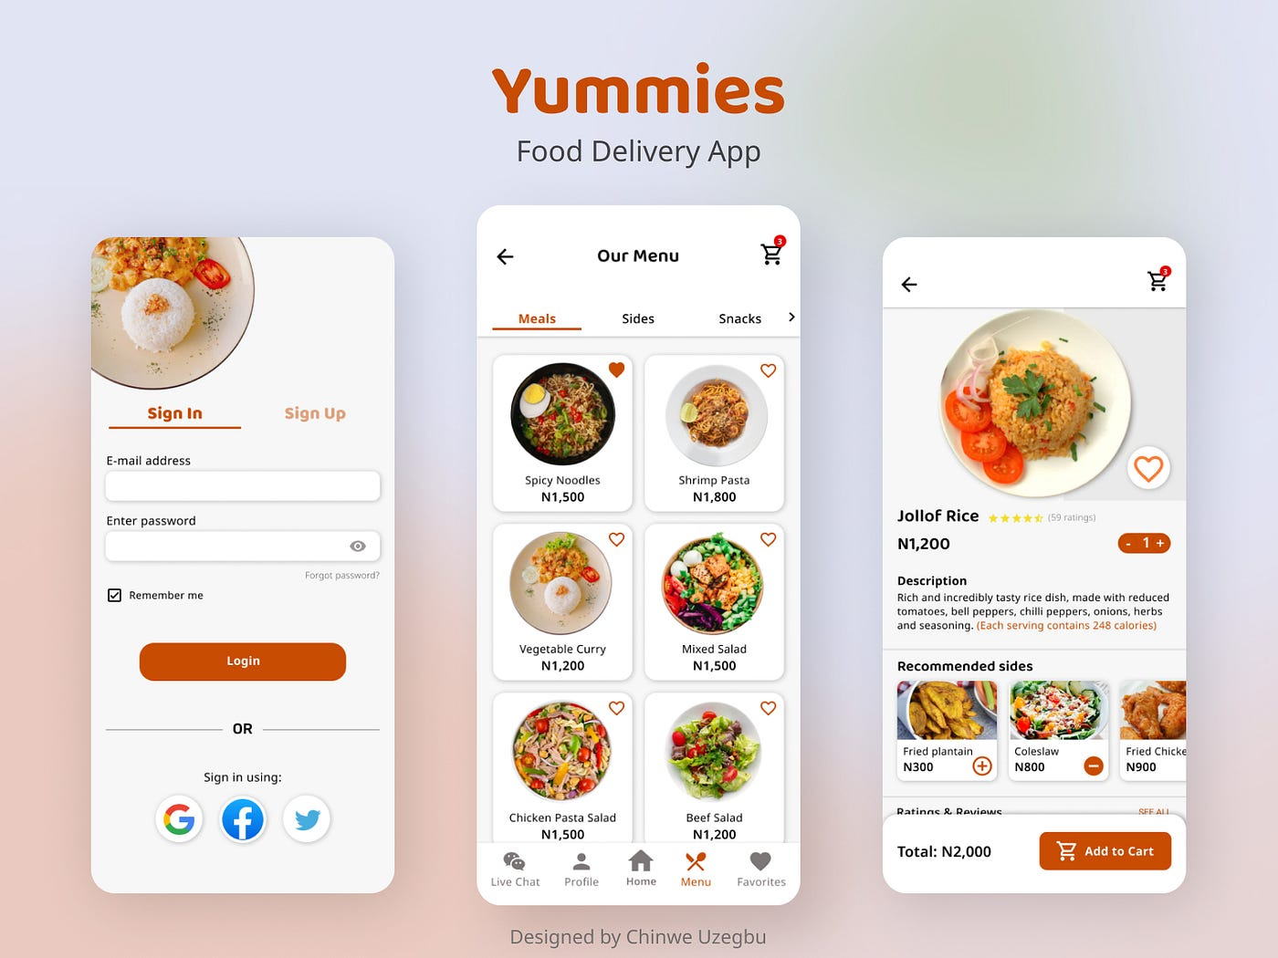

# RESULT:

Through this process, we have successfully developed a set of storyboards using Balsamiq that accurately depict the user flow of a mobile food delivery application. This storyboard aids in visualizing and planning the application's user experience, ensuring a smooth and intuitive interaction for users.